THE WORSHIP OF GOD
Sunday, October 31, 2021 | The God Who Answers Prayers
Please silence all electronic devices.

Gathering Music J. Noel Lance

Choral Introit Chancel Choir
God of Grace and God of Glory Paul Langston

Greeting Rev. Dennis W. Foust, PhD

*Call to Worship Rev. Nate Dove

ONE: We gather today to worship the One who created us,
ALL: The One who calls us,
ONE: The One who equips us,
ALL: The One who loves us without end.
ONE: With joyful hearts, let us worship God!

*Prayer of Submission Rev. Dove

*Hymn of Praise Immortal, Invisible, God Only Wise
Chalice Hymnal No. 66, verses 1 & 2 ST. DENIO

Immortal, invisible, God only wise,
in light inaccessible hid from our eyes,
most blessed, most glorious, the Ancient of Days,
almighty, victorious, Thy great name we praise.

Unresting, unhasting, and silent as light,
nor wanting, nor wasting, Thou rulest in might;
Thy justice like mountains high soaring above
Thy clouds which are fountains of goodness and love.

Reading from the Gospel of Matthew Mike Hall
Matthew 7:7-11

Ask, and it will be given to you; search, and you will find; knock, and the door will be opened for you. For everyone who asks receives, and everyone who searches finds, and for everyone who knocks, the door will be opened. Is there anyone among you who, if your child asks for bread, will give a stone? Or if the child asks for a fish, will give a snake? If you then, who are evil, know how to give good gifts to your children, how much more will your Father in heaven give good things to those who ask him!”

ONE: This is the written word of God for the people of God.
ALL: Thanks be to God!

Song of Response Seek Ye First
Chalice Hymnal No. 354 SEEK YE FIRST

Seek ye first the kingdom of God and God’s righteousness;
and all these things shall be added unto you. Allelu, alleluia!
Ask, and it shall be given unto you; seek, and ye shall find;
knock, and it shall be opened unto you. Allelu, alleluia!

Offertory Prayer Kimberly Allen

Offertory J. Noel Lance
A Mighty Fortress Jason Payne

*Doxology OLD HUNDREDTH

Praise God from whom all blessings flow;
praise God all creatures here below;
praise God above ye heavenly host:
Creator, Son and Holy Ghost. Amen.

The Church at Prayer Rev. Allison Benfield

Our Father, who art in heaven, hallowed be Thy name. Thy kingdom come, Thy will be done, on earth as it is in heaven. Give us this day our daily bread. And forgive us our debts, as we forgive our debtors. And lead us not into temptation, but deliver us from evil: For Thine is the kingdom and the power and the glory forever. Amen.

Prayer Concerns
Andrew Adair, Shirley Ballard, Katherine Barr, Carol Drye, Betty Fuller, Polly Hull, Jean Hutson, Barbara Ledford, Ashley Marin (granddaughter of the late Doris and Walt Tedder), Tish Philemon, Gene & Carol Poole, Viorica Secere, Don Swofford, Elma Thomas

Sympathy to Marc Cardella and family in the death of Marc's father

Moment for Reflection Jeff Almond

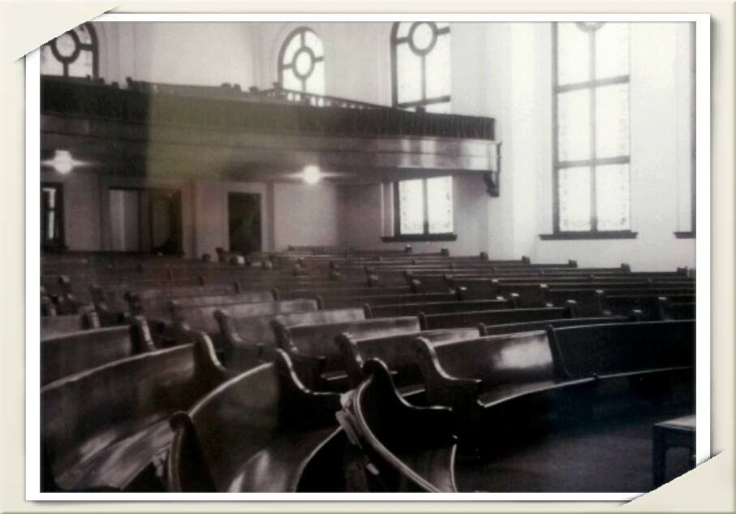
Early picture of the St. John’s Sanctuary

Song of Response Great Is Thy Faithfulness
Chalice Hymnal No. 86, verse 1 ST. DENIO

Great is Thy faithfulness, O God my Father,
there is no shadow of turning with Thee;
Thou changest not, Thy compassions, they fail not;
As Thou hast been, Thou forever wilt be.

Great is Thy faithfulness,
Great is Thy faithfulness,
Morning by morning new mercies I see;
all I have needed Thy hand hath provided -
Great is Thy faithfulness, Lord, unto me!

Message Rev. Dennis W. Foust, PhD
Great Expectations

*Song of Discipleship Standing on the Promises
Chalice Hymnal No. 552, verse 4 PROMISES

Standing on the promises I cannot fall,
list’ning every moment to the Spirit’s call,
resting in my Savior as my all in all,
standing on the promises of God.

Standing, standing,
standing on the promises of God my Savior;
standing, standing,
I’m standing on the promises of God.

Commissioning the Scattered Church Dr. Foust

Postlude

